TELCO CUSTOMER CHURN ANALYSIS
Business Analytics Case Study Report | Excel-Based Analysis

7,043  Total Customers | 1,869  Churned Customers | 26.5%  Avg Churn Rate | 5,174  Retained Customers | $139,131  Monthly Revenue at Risk | $16,056,169  Total Charges

Prepared by: Gift • AnalystLab Africa Internship • June 2026

1. Introduction

Customer churn — the rate at which subscribers discontinue service with a company — is one of the most consequential metrics in the telecommunications industry. Retaining an existing customer costs significantly less than acquiring a new one, making churn reduction a direct lever on profitability. This report presents a business analytics case study examining churn behaviour for a telecommunications provider, using a structured Excel-based analysis to identify risk patterns, surface actionable insights, and guide strategic decision-making.

2. Business Problem Statement

The company is losing approximately 26.5% of its customer base — more than one in four customers — within the observed period. Monthly revenue directly at risk from churned customers amounts to $139,131, with total charges across all churned accounts reaching $2,862,927. The business needs to understand:

- Which customer segments are most likely to churn and why?
- What contract, service, or billing patterns predict departure?
- Where should retention resources be focused for maximum impact?

Without these answers, the business risks continued revenue erosion, higher acquisition costs, and deteriorating customer lifetime value.

3. Dataset Description

The Telco Customer Churn dataset contains 7,043 records representing individual customers of a US telecommunications company. All analysis was performed entirely within Microsoft Excel. The dataset captures four categories of information:

Category | Variables | Purpose
Demographics | Gender, Senior Citizen, Partner, Dependents | Understand who the customer is
Account Details | Tenure, Contract Type, Paperless Billing, Payment Method | Understand how the customer engages
Services Used | Phone, Internet, Streaming, Security, Tech Support | Understand what the customer subscribes to
Financials | Monthly Charges, Total Charges | Quantify revenue contribution
Target Variable | Churn (Yes / No) | Outcome to be analysed and predicted

4. Data Analysis Process

All analysis was conducted in Microsoft Excel using the original dataset. The following steps were taken:

4.1 Data Cleaning & Preparation
- Inspected all 7,043 rows and 21 columns for missing values and data type consistency.
- No duplicate rows were found during the process; the raw dataset was kept intact, and all transformations were added as new columns.
- Converted the Senior Citizen column (originally 0/1 integer values) into a new descriptive text column labelled 'Senior Citizen Status' with values 'Non-Senior Citizen' and 'Senior Citizen' using an IF formula—improving readability in charts and pivot tables.
- Converted the Churn column (Yes/No text values) into a new numeric column, 'Churn (0/1),' using an IF formula, enabling mathematical aggregation (counts, averages, sums) in pivot tables.
- Verified the TotalCharges column for non-numeric entries and standardised formatting.

4.2 Analysis Techniques
- PivotTables were used to cross-tabulate churn rates against contract type, tenure bands, internet service, payment method, and demographic groups.
- Calculated fields and COUNTIF/AVERAGEIF formulas were used to derive segment-level churn percentages.
- Charts (bar, line, doughnut, and column) were built from PivotTable data and assembled into the final dashboard with a contract slicer for interactive filtering.
- KPI cards were created using cell references to summary aggregation cells.

5. Key Findings

The Excel dashboard and underlying pivot analysis surfaced the following statistically notable findings:

5.1 Contract Type Is the Strongest Churn Predictor
Contract Type | Churned Customers | Churn Rate
Month-to-Month | ~1,655 | 42.7%
One Year | ~166 | 11.3%
Two-Year | ~48 | 2.8%

Month-to-month customers churn at 15 times the rate of two-year contract holders. The dashboard's Contract slicer confirms this pattern holds across every other dimension analyzed.

5.2 Tenure — Early Months Are Critical
The Tenure Churn Trend line chart in the dashboard shows a clear, consistent relationship: churn declines sharply as tenure increases. Customers in the 0–11 month band show a churn rate exceeding 47%, which falls to below 7% for customers with 60–72 months of tenure. Churned customers average only 18 months of tenure versus 37.7 months for retained customers.

5.3 Fiber Optics Generate the Highest Internet Service Churn
Internet Service | Churned (Count) | Churn Rate
Fiber Optic | 1,297 | 41.9%
DSL | 499 | 19.0%
No Internet Service | 113 | 7.4%

Despite being the premium product, fiber optic customers churn at more than twice the DSL rate—a counterintuitive finding that points to pricing, service reliability, or expectation issues.

5.4 Electronic Check Payers Are the Highest-Risk Payment Segment
The Payment Method Churn bar chart shows 1,071 churned customers paid by electronic check—the largest single segment. Electronic check users churn at 45.3%, compared to approximately 15–16% for automatic payment methods (bank transfer and credit card). Customers paying by mailed check show a 19.2% churn rate.

5.5 Senior Citizens and Solo Customers Churn at Higher Rates
The Senior Citizen Churn bar chart records 476 churned senior citizens out of a smaller base, yielding a 41.7% churn rate versus 23.7% for non-seniors. The Partners Churn chart shows customers without a partner churn at 33.0% (1,200 churned) versus 19.7% (669 churned) for those with a partner. Similarly, the Dependants Churn chart shows customers without dependants at 31.3% versus 15.5% for those with dependants.

5.6 Tech Support and Device Protection Reduce Churn
The Tech Support Churn bar chart shows 1,446 churned customers had no tech support—a churn rate of 41.6%—versus only 310 churned among those subscribed to tech support (15.2%). The Device Protection Churn chart reflects a similar pattern, confirming that add-on services materially reduce the likelihood of departure.

5.7 Paperless Billing Correlates with Higher Churn
The Paperless Billing Churn donut chart shows 1,400 churned customers (Yes) versus 469 (No). Customers on paperless billing churn at 33.6%, double the 16.4% rate of those on paper billing—likely overlapping with the digitally-engaged, month-to-month, higher-risk segment.

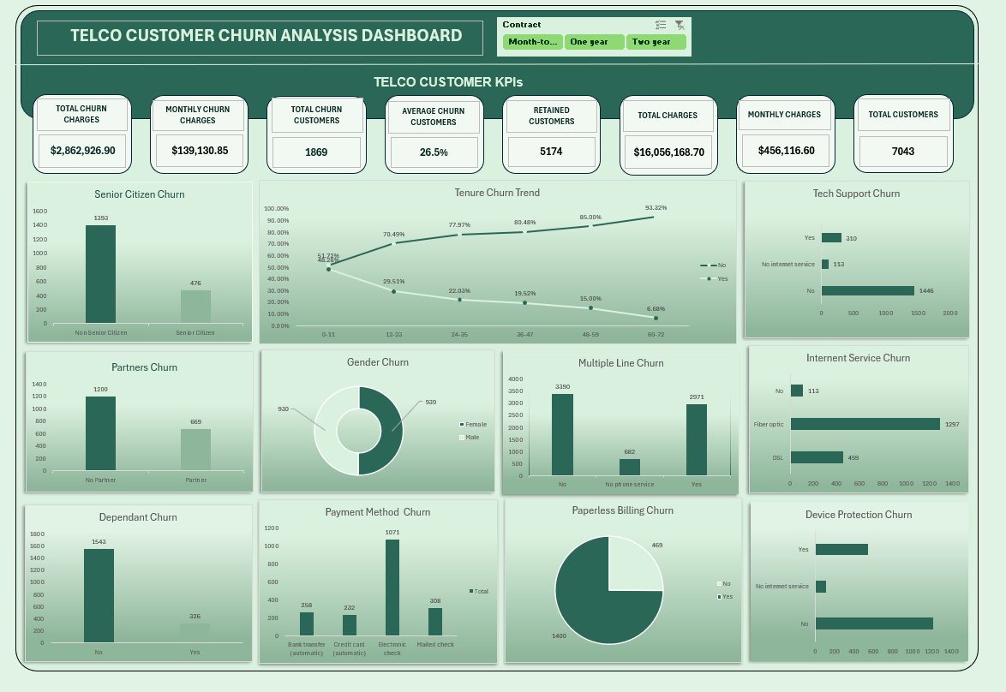

6. Business Insights

What Patterns Were Discovered?
• Churn is strongly structural, not random—contract type, tenure, and service type each create predictable risk tiers.
• Risk declines linearly with time: every additional year of tenure roughly halves the probability of churn.
• Automatic payment adoption is a reliable proxy for customer commitment—those on auto-pay churn at one-third the rate of manual payers.
• Add-on services (Tech Support, Device Protection, Online Security) act as loyalty anchors, dramatically reducing churn in each case.

What Customer Behaviours Stood Out?
• Month-to-month customers exhibit low-commitment, trial-like behavior—42.7% leave, indicating the product has not yet earned long-term loyalty from this group.
• Fiber optic subscribers, despite paying more, are leaving at the highest rate of any internet service group—a signal of unmet expectations or service dissatisfaction.
• Electronic check users show the lowest billing automation and the highest churn, suggesting disengagement from the brand.
• New customers (0–12 months) are in a high-risk window: nearly half leave before completing their first year.

Which Customer Segments Require Immediate Attention?
• Month-to-month contract holders — 42.7% churn rate, representing the largest volume of churned customers.
• New customers in months 0–12 — 47.7% churn rate; the onboarding experience is clearly insufficient.
• Fiber optic subscribers — 41.9% churn rate despite being the premium product tier.
• Senior citizens — 41.7% churn rate, potentially reflecting affordability concerns or service complexity.
• Electronic check payers — 45.3% churn rate; the highest of any payment method group.

What Risks and Opportunities Exist?
• RISK: $139,131 in monthly recurring revenue is lost each month with no retention mechanism currently in place for high-risk segments.
• RISK: Fiber optic churn at 41.9% could generate negative word-of-mouth, harming brand perception in the premium market segment.
• OPPORTUNITY: Customers with add-on services churn at ~14–15% — bundling these services more aggressively could lift overall retention significantly.
• OPPORTUNITY: Converting electronic check users to auto-pay could reduce their churn by up to 30 percentage points based on observed differentials.
• OPPORTUNITY: Long-tenure customers (49–72 months) are highly stable at 9.5% churn — understanding what keeps them loyal can inform new customer programmes.

7. Recommendations

Recommendation 1: Introduce a Contract Migration Incentive Programme
Target: Month-to-month customers | Expected Impact: HIGH

Design a structured incentive for month-to-month customers to upgrade to annual or two-year contracts. Offer a meaningful reward — such as one month free, a discounted monthly rate, or a bundled add-on service — to customers who commit to a longer term. Prioritise customers approaching their 6-month mark, as this appears to be a key decision point. Even converting 25% of month-to-month customers to one-year contracts could reduce total churn by 4–6 percentage points.

Recommendation 2: Build a Structured First-Year Onboarding Journey
Target: New customers (0–12 months) | Expected Impact: HIGH

Nearly half of all new customers leave within their first year — a preventable outcome. Implement a 90-day onboarding programme with proactive communication touchpoints at Day 7, Day 30, and Day 60. Ensure new customers understand and actively use at least one add-on service within the first month, as subscribers to Tech Support or Security churn at approximately one-third the rate. Flag customers with no service engagement by Week 3 for personal outreach.

Recommendation 3: Launch an Auto-Pay Conversion Campaign
Target: Electronic check payers | Expected Impact: MEDIUM-HIGH

Electronic check users churn at 45.3% — nearly three times the rate of automatic payment customers. Offer a small monthly bill credit (e.g., $3–$5/month) as an incentive for customers to switch to bank transfer or credit card auto-pay. Simplify the switch process within the billing portal and include the offer in the next billing cycle communication. This single intervention could recover a meaningful portion of the 1,071 churned electronic check customers annually.

Recommendation 4: Investigate and Address Fiber Optic Dissatisfaction
Target: Fiber optic internet subscribers | Expected Impact: HIGH

The 41.9% churn rate among fiber optic customers is the most strategically dangerous finding in this analysis. Commission a targeted customer satisfaction survey specifically for this group and review service complaint data. If pricing is the issue, consider introducing a loyalty-based rate reduction after 12 months. If reliability is the concern, invest in service-level improvements and consider a proactive service guarantee credit. A fiber customer who stays becomes one of the company's most valuable long-term accounts.

Recommendation 5: Bundle Add-On Services to Increase Stickiness
Target: Internet customers without Tech Support or Device Protection | Expected Impact: MEDIUM

Tech Support and Device Protection each reduce churn by roughly 65% in the observed data. Introduce a discounted bundle that combines internet service with at least one of these add-ons and offer a 30-day free trial to high-risk customers at the point of onboarding or contract renewal. Cross-sell these services proactively during customer service interactions and embed prompts in the self-service portal.

8. Conclusion

This Excel-based business analytics case study demonstrates that customer churn at this telecommunications company is not random — it follows predictable, addressable patterns. A 26.5% overall churn rate translating into $139,131 of monthly revenue at risk is a significant but solvable problem, with clear structural drivers identified across contract type, tenure, service type, and payment behaviour.

The analysis confirms that long-term contract commitment, early customer engagement, add-on service adoption, and automatic billing are the four strongest predictors of customer retention. Conversely, month-to-month contracts, the first year of service, Fiber optic subscriptions, and electronic check payment each represent concentrated risk zones requiring targeted intervention.

If the five recommendations in this report are implemented in sequence — starting with the contract migration programme and first-year onboarding redesign — the company has a realistic pathway to reducing its overall churn rate by 8–12 percentage points, recovering hundreds of thousands of dollars in monthly recurring revenue, and building a more loyal, higher-value customer base over time.

Key Takeaway

7,043 customers analysed • 1,869 churned (26.5%) • $139,131 monthly revenue at risk • Month-to-month contracts (42.7%) and first-year customers (47.7%) are the highest-risk groups. • Add-on services reduce churn by up to 65% • Auto-pay adoption is the simplest, fastest win available.

— End of Report —

